# Lab A1: Functional Programming

## Objectives

In this lab you will write some basic code using the Java functional programming constructs so perform some basic operations on data. The purpose of this lab is to get you familiar with the using the basic functional programming building blocks provided by Java

## Lab Setup

Create a basic Java project with a single class called Demo with a main() method. This class will only be used to provide a way to run your code as a Java application

## Part One

1. Create the three basic types of Functional methods as depicted in the notes;
   1. Function
   2. BiFunction
   3. Predicate
2. Keep the functions simple.
3. Try composing several of the functions (remember f(g(x))) but ensure that the datatypes line

## Part Two

1. Run the following code and explain why it worked the way it did. Hint: recall the definition of functions as first class objects.

## Part Three

1. Based on what was in the slides, create a thread without using any declared variables.

## Part Four

1. 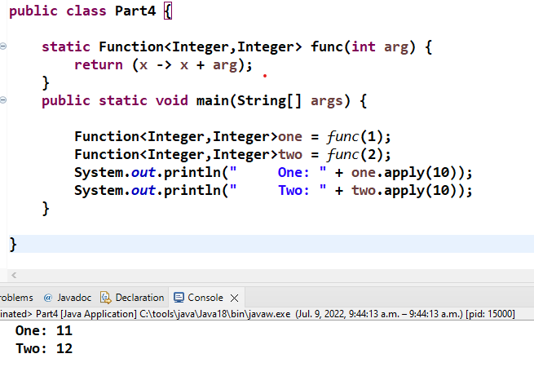Execute the following code and explain the results.